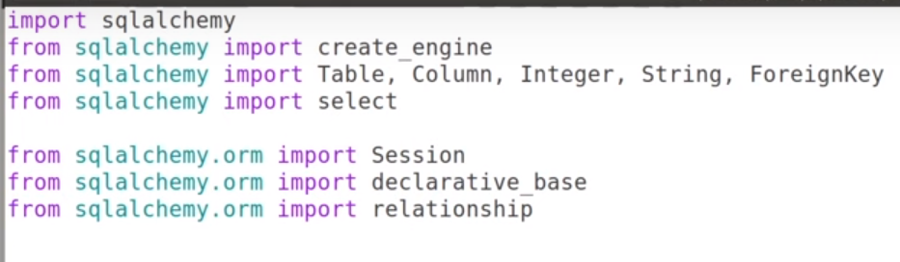



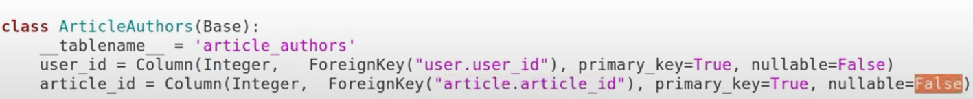

SQLAlchemy relations

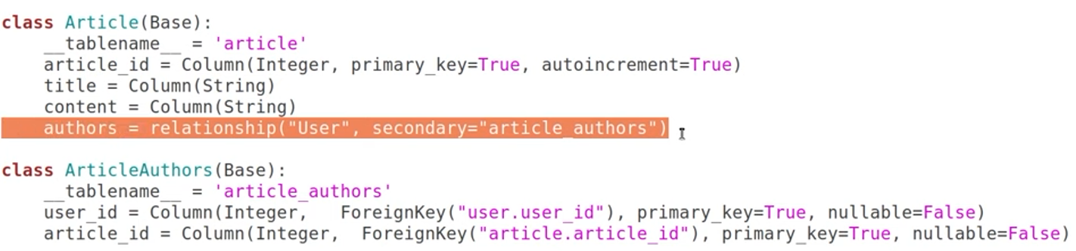

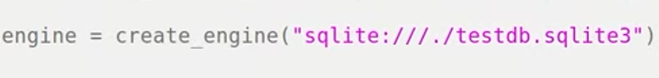

Instead of using connect every time, we can create a session





